$we understood the linear regression equation$

$Read the data$

$Preprocess or EDA of the data , represent as numerical data$

$develop the model ( X_{train}, y_{train})$

$Evaluate the model \left( X_{test}data\right)$

$Performance metrics$

$Tune the model$

$Deploy the model$

$$develop the model: Linear regression model$$

$$y=b_{o}+b_{1}*x$$

$$to find the suitable coeffiecients in order to minmize the cost$$

$$that coefficents will find OLS method$$

$$assume that we found b_{o} and b_{1} on X_{train} and y_{train} ==== > Model is developed$$

$$will pass x_{test} to the developed model , model gives y_{predictions}$$

$$we need to compare y_{test} with y_{predictions}$$

$$This is high level understanding$$

$$But after the model development happens$$

$Under fit \left( The model not trained well on train data itself\right)$

$after develop the model , we again pass only X_{train}$

$the output given by model wil compare with y_{train}$

${\left(y_{train}-y_{predictions}\right)}^{2}= Train error$

$Normal fit$

$The model trained well on train data, when you pass test data$

$It is giving good predections$

$Train error is less and Test error also less$

$Over fit$

$The model trained but not able to identify the patterns$

$It gives train error less, but test error is more$

$$More train error=== > Underfit$$

$$Less Train error -Less Test error === >Normal fit$$

$$Less Train error-More Test error=== >Overfit$$

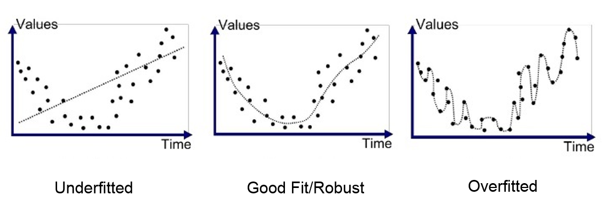

$$Bias-Variance Trade off$$

$$Bias$$

$As you incresae the complexity of model, which means if add more variables in development of model$

$Bias curve will reduce$

$Bias is analogy with train error$

$As model complexity increases , bias will decresae and train error also decrease$

$$Variance$$

$As you incresae the complexity of model, which means we are adding more varaiables$

$Variance curve will be increase$

$Variance is analogy with Test error$

$As model complexity increases, variance will increase and test error also incresae$

$$The main aim behind bias and variance curve is$$

$$How many features or variables need to use to develop the model$$

$$what is the impact of feature selection$$

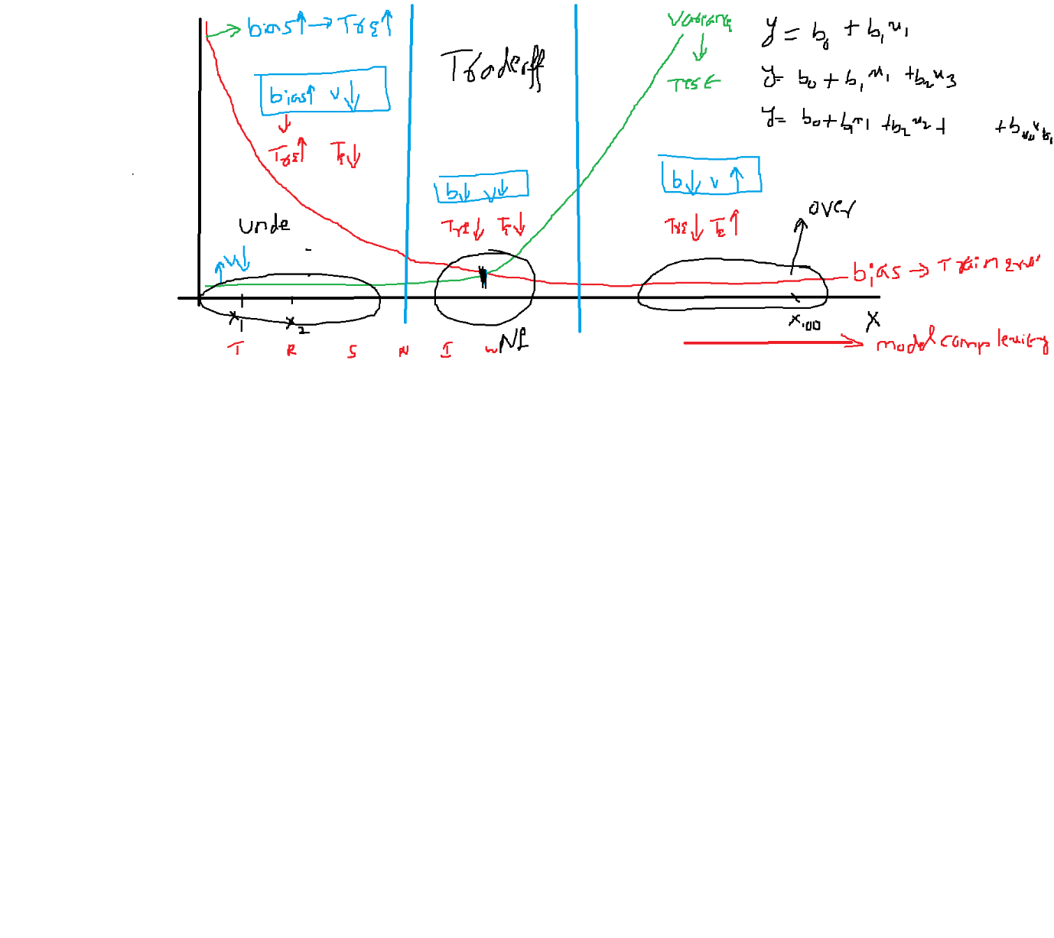

$$the diagram divided into 3 parts$$

$Less variables include to develop the model$

$we might miss the further important varaibles$

$The model will not ables to provide good patterns$

$It is not trained well on train data itslef$

$In this senario bias is very high- Variance is low == >Under fit$

$optimal variables which are important include to develop the model$

$The model will ables to provide good patterns$

$In this senario bias is low- Variance is low == >Normal fit$

$All the variables include to develop the model$

$It is not a good idea to include all the variables to develop model$

$Some of the unimportant variables cause to stop the model thinking$

$In this senario bias is very low- Variance is high== >Over fit$

$$low bias \left(Train error low\right)-highe variance \left( Test error is hight\right)= Overfit$$

$$high bias \left( Train error is high\right)-low varaince= Underfit$$

$$low bias \left(Train error is low\right)-low variance\left(test error is low\right)=Normalfit$$

$$bias=difference y_{a} and y_{p}$$

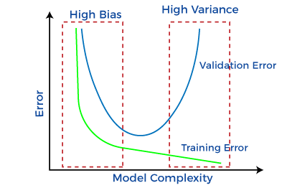

$what cause model become underfit and overfit$

$$if you use all the columns or features then model become overfit$$

$$if you use less columns then model become underfit$$

$$Feature selection concept$$

Sir when variance is high then how bias can be low??

Your model gives train error less and when you test on unseen data the error is more

No model gives 100% accuracy on train data

If you are getting this :

We want to detect the numbers on the instruments

If you not detect it cause a main problem

Annotation job

Generative AI : NLP Images

SORA video

Python 3months

SORA ====== SORA

Metrics

RSE

R-square

Adjusted R-square

Hypothesis

Saturday by assumptions